Tim Glass
Hansford County Judge 16 Northwest Court
Speannan, Texas 79081-2052
Office:: 806-659-4 I 00
Email:j udgeglass@hansfordcoun tytx. com

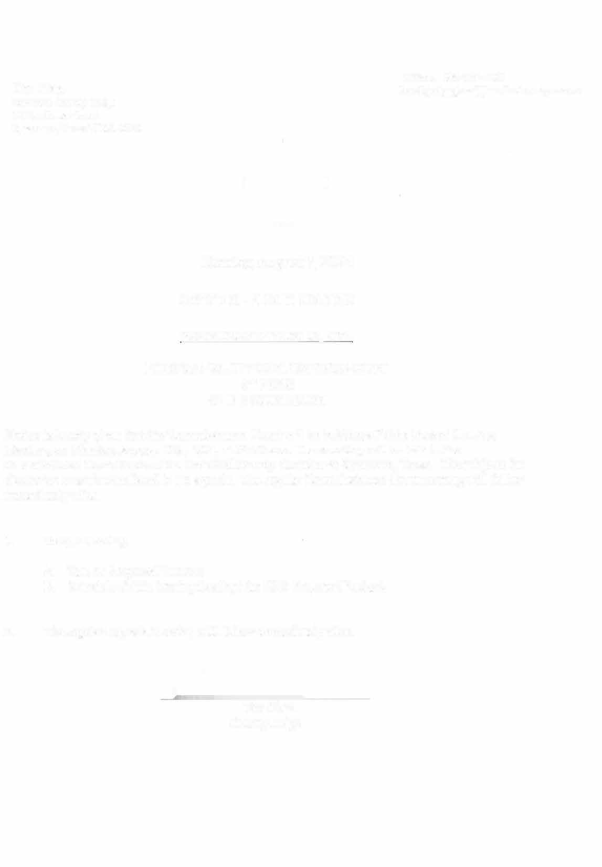



Tuesday August 11, 2026

NOTICE OF PUBLIC HEARING

FOR MONDAY AUGUST 24, 2026

HANSFORD COUNTY COMMISSIONERS COURT
3 RD FLOOR
OF THE COURTHOUSE

Notice is hereby given that the Commissioners Court will be holding a Public Budget Hearing Meeting on Monday, August 24th, 2026, at 09:50 a.m. The meeting will be held in the Commissioner Court Room of the Hansford County Courthouse, Spearman, Texas. The subjects for discussion or action are listed in the agenda. The regular Commissioners Court meeting will follow immediately after.

- Budget Hearing
A. Budget Hearing Proposed 2026 Budget

- The regular Agenda Meeting will follow immediately after.

Tim Glass County Judge

